Select source of image uploading

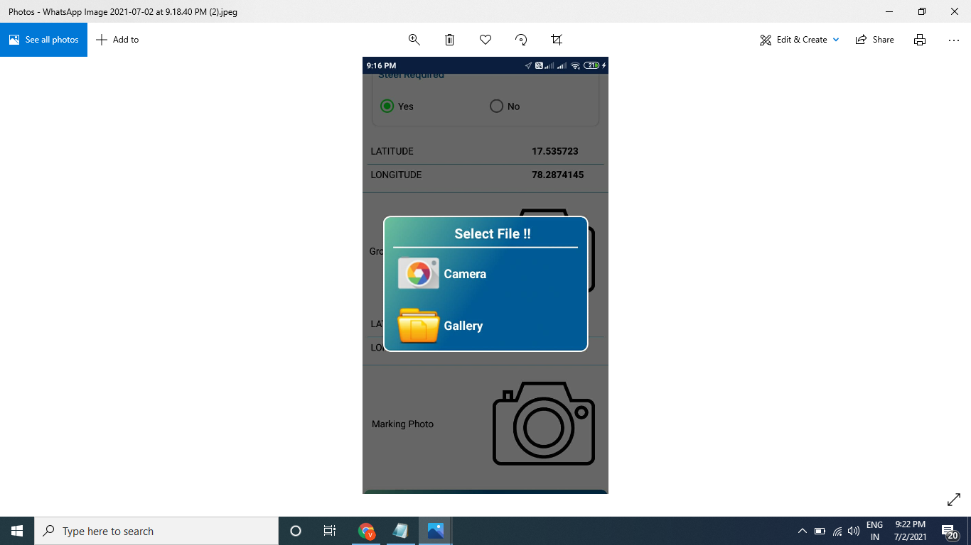

Select Camera to proceed further for Grounding Photo

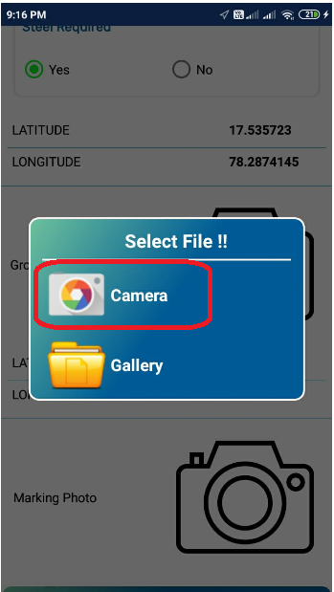

Take a photo and then select to proceed

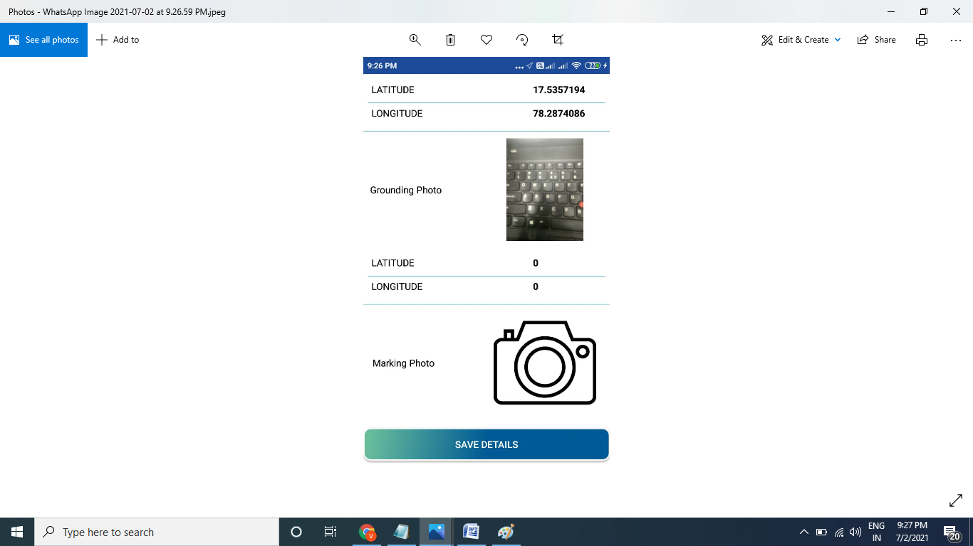

Select Gallery to upload photo for Marking Photo

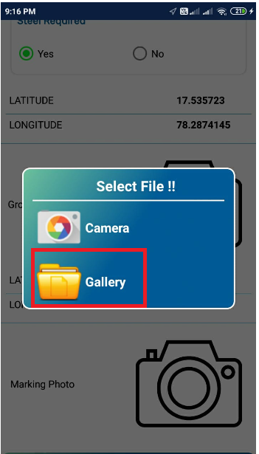

Select the images from Gallery as shown below

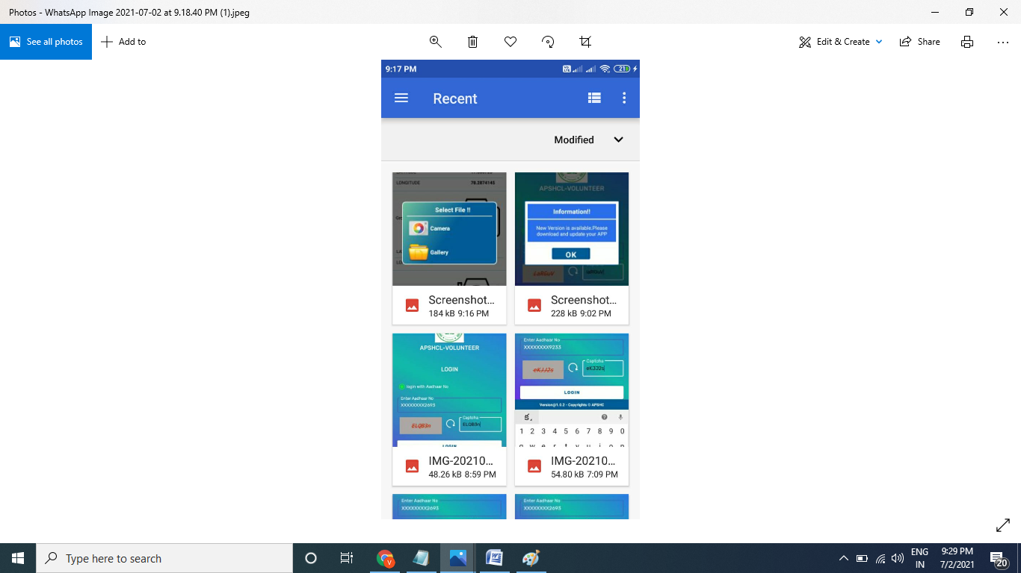

Both the images uploaded and shown as below. Then click on Save Details to complete the application

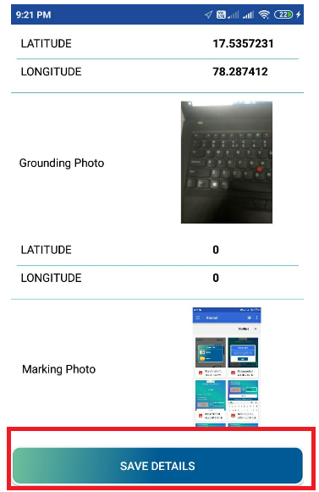

Success message shows as below

